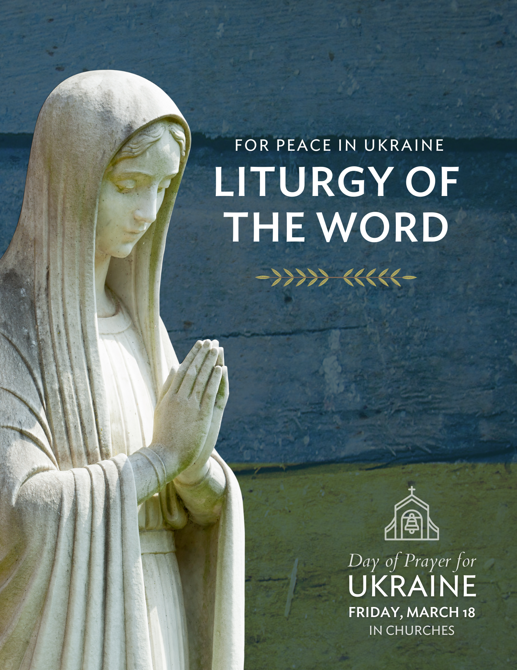

Liturgy of the Word
FOR PEACE IN UKRAINE

ENTRANCE SONG OR VERSE BELOW

Minister: The Lord said: I think thoughts of peace and not of affliction.
You will call upon me, and I will answer you,
and I will lead back your captives from every place.
Jeremiah 29:11-12, 14. Page 1288, The Roman Missal, Canadian Edition.
Copyright © Concacan Inc., 2011. All rights reserved.

THE SIGN OF THE CROSS

Minister: In the name of the Father, and of the Son, and of the Holy Spirit.

All: Amen.

Minister: The Lord be with you.

All: And with your spirit.

INTRODUCTION

Minister: With hope in God’s loving mercy and deep sorrow and concern for those who are suffering in Ukraine because of war, we turn our hearts to the Lord, trusting that he knows our every need.
COLLECT

Minister: Let us pray.

Minister: God of реасе and justice,
we pray for the реорlе of Ukraine today.
We pray for реасе and the laying down of weapons.
We pray for аІІ those who fear for tomorrow,
that your Spirit of comfort would draw near to them.
We pray for those with power over war or реасе,
for wisdom, discernment and compassion to guide their decisions.
Above all, we pray for all your precious children, at-risk and in fear,
that you would hold and protect them.
We pray in the name of Jesus, the Prince of Реасе.

All: Amen.

FIRST READING MICAH 4:1-4

Reader: A reading from the book of the prophet Micah.
In days to come
the mountain of the Lord’s house
shall be established as the highest of the mountains,
and shall be raised up above the hills.
Peoples shall stream to it,
and many nations shall come and say:
“Come, let us go up to the mountain of the Lord,
to the house of the God of Jacob;
that he may teach us his ways
and that we may walk in his paths.”
For out of Zion shall go forth instruction,
and the word of the Lord from Jerusalem.
He shall judge between many peoples,
and shall arbitrate between strong nations far away;
they shall beat their swords into plowshares,
and their spears into pruning hooks;
nation shall not lift up sword against nation,
neither shall they learn war any more;
but they shall sit under their own vines
and under their own fig trees,
and no one shall make them afraid;
for the mouth of the Lord of hosts has spoken.
The word of the Lord.

All: Thanks be to God.

Page 573, Lectionary: Ritual Masses, Masses for Various Needs and Occasions,
Votive Masses, Masses for the Dead, Study Edition, copyright © Concacan Inc., 2014.
All rights reserved.

RESPONSORIAL PSALM PSALM 85:8AB-9, 10-11, 12-13

Reader: The Lord speaks peace to his people.

All: The Lord speaks peace to his people.

Reader: Let me hear what God the Lord will speak,
for he will speak peace to his people.
Surely his salvation is at hand for those who fear him,
that his glory may dwell in our land.

All: The Lord speaks peace to his people.

Reader: Steadfast love and faithfulness will meet;
righteousness and peace will kiss each other.
Faithfulness will spring up from the ground,
and righteousness will look down from the sky.

All: The Lord speaks peace to his people.

Reader: The Lord will give what is good,
and our land will yield its increase.
Righteousness will go before him,
and will make a path for his steps.

All: The Lord speaks peace to his people.

Page 577, Lectionary: Ritual Masses, Masses for Various Needs and Occasions,
Votive Masses, Masses for the Dead, Study Edition, copyright © Concacan Inc., 2014.
All rights reserved.

GOSPEL ACCLAMATION

Glory and praise to you, Lord Jesus Christ!
Blessed are the peacemakers; for they shall be called children of God.
Glory and praise to you, Lord Jesus Christ!

Page 577, Lectionary: Ritual Masses, Masses for Various Needs and Occasions,
Votive Masses, Masses for the Dead, Study Edition, copyright © Concacan Inc., 2014.
All rights reserved.

GOSPEL READING MATTHEW 5:1-12A

Minister: The Lord be with you.

All: And with your spirit.

Minister: A reading from the holy gospel according to Matthew.

All: Glory to you, O Lord.

Minister: When Jesus saw the crowds, he went up the mountain;
and after he sat down, his disciples came to him.
Then he began to speak, and taught them, saying:
“Blessed are the poor in spirit,
for theirs is the kingdom of heaven.
Blessed are those who mourn,
for they will be comforted.
Blessed are the meek,
for they will inherit the earth.
Blessed are those who hunger and thirst for righteousness,
for they will be filled.
Blessed are the merciful,
for they will receive mercy.
Blessed are the pure in heart,
for they will see God.
Blessed are the peacemakers,
for they will be called children of God.
Blessed are those who are persecuted for righteousness’ sake,
for theirs is the kingdom of heaven.
Blessed are you when people revile you and persecute you
and utter all kinds of evil against you falsely on my account.
Rejoice and be glad,
for your reward is great in heaven.
The Gospel of the Lord.

All: Praise to you, Lord Jesus Christ.

Pages 555-556, Lectionary: Ritual Masses, Masses for Various Needs and Occasions,
Votive Masses, Masses for the Dead, Study Edition, copyright © Concacan Inc., 2014. All
rights reserved.
HOMILY / SERMON

PRAYER OF THE FAITHFUL

Minister: Let us intercede before God, whose hand provides for the needs of all.

Reader: For the Church, that it may lead efforts for peace and justice
through prayer and a call to dialogue, we pray to the Lord:

All: Lord, hear our prayer.

Reader: For nations at war, that hostilities may cease and reconciliation prevail,
we pray to the Lord:

All: Lord, hear our prayer.

Reader: For the nations of the world, that they may open their hearts to generously respond to the needs of those fleeing from war, we pray to the Lord:

All: Lord, hear our prayer.

Reader: For those who suffer from acts of war, especially for the victims in Ukraine, that they may be delivered from strife, we pray to the Lord:

All: Lord, hear our prayer.

Reader: For families, separated by war, that they may be safely reunited,
we pray to the Lord:

All: Lord, hear our prayer.

Reader: For the member of this assembly, that we may be peacemakers
who never cease to work for harmony and love, we pray to the Lord:

All: Lord, hear our prayer.

Reader: For those who have died because of the war in Ukraine, that they may be welcomed into the peace and light of God’s heavenly kingdom and find rest,
we pray to the Lord:

All: Lord, hear our prayer.

Minister: O God, who looks upon the suffering of your people with the eyes of compassion, have mercy on the world and grant us your peace. Through Christ our Lord.

All: Amen.
THE LORD’S PRAYER

Minister: At the Saviour’s command and formed by divine teaching, we dare to say:

All: Our Father, who art in heaven,
hallowed be thy name;
thy kingdom come;
thy will be done on earth as it is in heaven.
Give us this day our daily bread;
and forgive us our trespasses
as we forgive those who trespass against us;
and lead us not into temptation,
but deliver us from evil.

Minister: Deliver us, Lord, we pray, from every evil,
graciously grant peace in our days, that, by the help of your mercy,
we may be always free from sin and safe from all distress,
as we await the blessed hope and the coming of our Saviour, Jesus Christ.

All: For the kingdom, the power and the glory are yours, now and forever.

SIGN OF PEACE (optional, limited to a simple bow toward one another)

Minister: Lord Jesus Christ, who said to your Apostles:
Peace I leave you, my peace I give you,
look not on our sins, but on the faith of your Church,
and graciously grant her peace and unity
in accordance with your will.
Who live and reign for ever and ever.

All: Amen.

Minister: The peace of the Lord be with you always.

All: And with your spirit.

Minister: Let us offer each other the sign of peace.

CONCLUDING PRAYER

Minister: Let us pray.

Minister: Grant to us, O Lord,
that enlivened by the Sacred Word
that fortifies the human heart,
we may successfully overcome the fury of war
and resolutely keep your law of love and justice.
Through Christ our Lord.

All: Amen

Adapted from the Prayer after Communion, Page 1289, The Roman Missal,
Canadian Edition. Copyright © Concacan Inc., 2011. All rights reserved.

BLESSING AND DISMISSAL

Minister: The Lord be with you.

All: And with your spirit.

Minister: May almighty God bless you, the Father, † and the Son,
and the Holy Spirit.

All: Amen.

Minister: Go in peace.

All: Thanks be to God.

RECESSIONAL HYMN/SONG

===============
ADDITIONAL SUGGESTIONS
- Pray a Litany for Peace: Microsoft Word - Litany for Peace.doc (paxchristiusa.org)
- Seek the intercession of the holy men and women of Ukraine: Litany for Ukraine: Holy saints and martyrs, pray for peace (aleteia.org)

